BIPOC Mental Health Month – “Rejuvenating July” Calendar, 2023

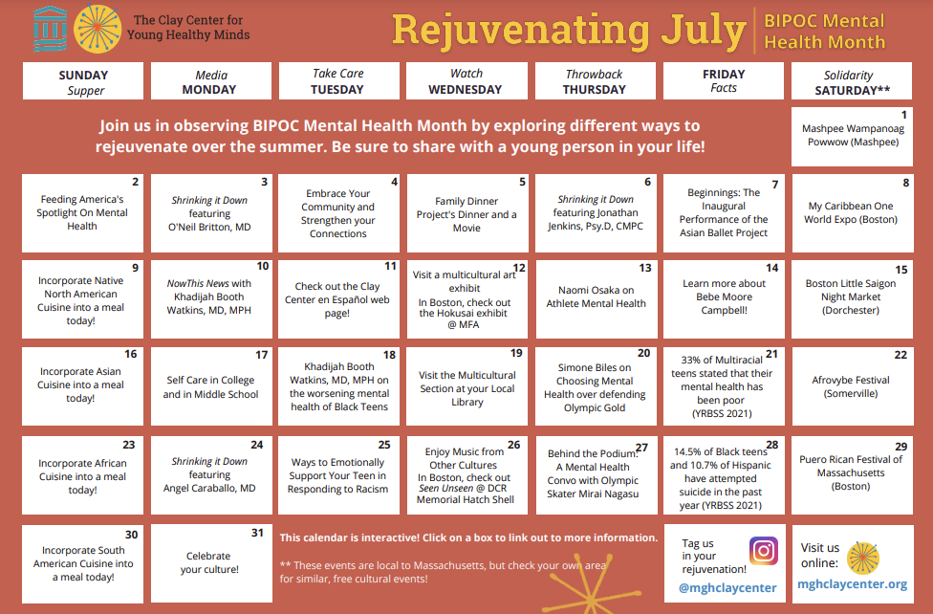
More info at: https://www.mghclaycenter.org/multimedia/bipoc-july/
July 1:
Mashpee Wampanoag Powwow
When: 10 am – 6pm
Where: 483 Great Neck Road South, Mashpee MA 02649
Description: The 102nd Annual Pawâw will return to Mashpee on July 1, 2, and 3. The 2023 annual pawâw features special events, contests, food, vendors, drumming and dancing will be held on the Pawâw Grounds at the Mashpee Wampanoag Tribe Community and Government Center.

Chinatown Main Street Summer Festival
When: 10 am – 6pm
Where: Rose Kennedy Greenway
Description: Swing on by and enjoy the annual Chinatown Main Street Summer Festival with food vendors, street shops, and live performances!

July 2:
Feeding America’s Spotlight on Mental Health

July 3:
Shrinking It Down: Moving Toward Anti-Racism for Our Future Generations, featuring O’Neil Britton, MD
Description: On this episode of Shrinking It Down, special guest O’Neil Britton, MD, chief medical officer and senior vice president of Massachusetts General Hospital, joins Gene Beresin for a conversation about continued racial inequities in our society, social justice, and our duty to do better for future generations. They discuss the effects of structural racism built into education and healthcare systems on kids and families, and think critically about steps we must take – individually and institutionally – to do more in moving towards an anti-racist Boston, and an anti-racist America.

July 4:
Celebrate the theme of this year’s BIPOC Mental Health Month: Culture, Community, and Connection

July 5:
The Family Dinner Project’s Dinner and a Movie

July 6:
Shrinking It Down: Young People, Sports, and Mental Health, featuring Dr. Jonathan Jenkins, Psy.D, CMPC
Description: In this must-listen episode, Dr. Jonathan Jenkins of the Sport Psychology Program at Mass General joins Gene and Khadijah to discuss all things sports psychology and how best to support our young people in this important area of their lives. Whether your child dreams of being a professional or just likes to play for fun, tune in to learn how parents and coaches can promote a healthy mindset around sports and physical activity.

July 7:
Beginnings: Inaugural Performance of the Asian American Ballet Project
Tickets: $15-60
When: 4 pm – 5:30 pm
Where: Multicultural Arts Center 41 Second Street Cambridge, MA 02141
Description: Witness the very first Asian American ballet company as the Asian American Ballet Project takes to the stage in their inaugural performance Beginnings. Prepare to be captivated as our company dancers breathe new life into the classic christening scene from Sleeping Beauty. Transport yourself to ancient Mongolia with "Suho and the White Horse," a compelling ballet that unveils the dramatic origin story of the horse-head fiddle. Be among the first to behold two groundbreaking world premieres that push the boundaries of creativity and expression. Join us for Beginnings and walk away inspired by the power of Asian American artistry.

July 8:
My Caribbean One World Expo
When: 11 am – 7pm
Where: Rowes Wharf Boston, MA 02110
Description: Join the Authentic Caribbean Foundation for the annual, “My Caribbean One World Expo.” Celebrating 10 years, the Expo will continue to promote the diverse Caribbean Diaspora Community through Arts, Heritage, Culture and Tourism. Highlights of the Caribbean festival include Caribbean community culture, arts and craft, entertainment, and destination on display.

July 9:
Indigenous American cuisine:
Three Sisters Soup
Blue Corn Mush
Other Recipes

July 10:
NowThis News: Khadijah Booth Watkins, MD, MPH on the increase in the rate of suicide among Black Youth
Description: Black children aren’t getting the mental health care they need, says this child psychiatrist, as the U.S. sees an increase in rate of suicide among Black youth. Here’s what needs to change

July 11:
Check out the Clay Center en Español page and other translated articles

July 12:
Visit a Multicultural Art Exhibit:
Museum of Fine Arts Boston: Hokusai: Inspiration and Influence
The Met: Juan de Pareja, Afro-Hispanic Painter
LA County Museum of Art: Women Defining Women in contemporary Art of the Middle East and Beyond

July 13:
Naomi Osaka – Shining Light on Athlete Mental Health

July 14:
Learn more about the namesake for BIPOC Mental Health Month, Bebe Moore Campbell:
Brief History
72 Hour Hold
Other Links

July 15:
Boston Little Saigon Night Market
When: 4 pm – 9 pm
Where: Town Field Park and Dorchester Ave between Park and Adams st, Field's Corner, Dorchester, MA 02125
Description: Special attractions include a diverse line-up of entertainment, games and activities for all ages, a beer garden, Instagram worthy photo opportunities, and a diverse range of street foods! Night markets are outdoor street festivals that include food vendors, artisan/merchandise vendors, games, entertainment, and photo opportunities. They can be found all over Vietnam and are one of the most loved experiences by locals and tourists. Boston Little Saigon Cultural District is rich with culture and history. The night market will be a fun way to get a “taste” of everything Boston Little Saigon has to showcase in a fun-filled evening.

July 16:
Asian Cuisine:
Chicken Biryani
Kimchi
Karaage Rice Bowl

July 17:
Self-Care in College
Self-Care in Middle School
Description: We all face stresses in life – schoolwork, conflict with peers, and more. How can we cope? In this series of videos on self-care, we hear from students in middle school, high school, and college about the stresses in their lives and how they practice self-care to manage. NOTE: The stories shared cover a range of topics that some viewers may find sensitive in nature, including mention of bullying, gender identity, and self-harm. Please see below for additional resources on these topics.

July 18:
Word in Black: Black Teens are Suffering in Silence

July 19:
Visit the Multicultural Section at your Local Library

July 20:
Simone Biles – Choosing Mental Health Over Defending Olympic Gold

July 21:
Youth Online: High School YRBS - 2021 Results | DASH | CDC 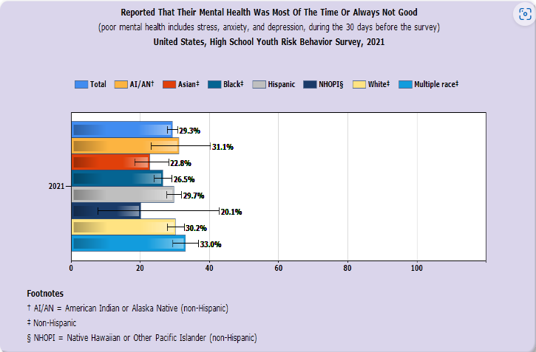

July 22:
Afrovybe Festival
When: 12 pm – 8 pm
Where: 1 Bow Market Way, Somerville, MA 02143
Description: AfroVybe is a cultural extravaganza that will leave you awe-inspired, enriched, and connected to the vibrant tapestry of African heritage. Come celebrate and immerse yourself in a bustling Vendor Market, overflowing with vibrant fabrics, handcrafted jewelry, and unique artifacts, each telling a story steeped in African heritage. Adorn yourself with exquisite henna artistry, as intricate patterns are delicately traced onto your skin, celebrating the beauty and intricacy of African design. And don't forget to visit the waist beads tying station, where skilled artisans will fashion colorful strands that serve as a symbol of femininity, sensuality, and cultural pride. So, join us in this unmissable celebration where music, food, art, and community converge, creating an unforgettable experience that will resonate in your soul long after the final note fades away.

July 23:
African Cuisine:
Jollof Rice
Doro Wat
Chakalaka
Chicken Tagine

July 24:
Shrinking It Down: Mental Health Challenges and Latinx Children and Teens, featuring Angel Caraballo, MD
Description: On today’s episode of Shrinking It Down, Gene and Khadijah welcome special guest Dr. Angel Caraballo for a conversation about the unique mental health challenges impacting Latinx and Hispanic families. From his experience as a child and adolescent psychiatrist and also as a parent, Dr. Carraballo help us to think more about ways to address stigma and other barriers to accessing mental health care within Latinx communities.

July 25:
Ways to Emotionally Support Your Teen in Responding to Racism and Racialized Violence

July 26:
Enjoy the Music of other Culture:
Seen-Unseen: The Symphonic Legacy of Black American Women
When: 7 pm - 9 pm
Where: Hatch Memorial Shell 47 David G Mugar Way, Boston, MA, 02114-3214
Description: Coinciding with the NAACP’s conference in Boston, the July 26th concert at the Hatch Shell brings a special focus to celebrating the symphonic legacy of Black American women and their compositions. Grammy award-winning drummer, producer and educator, Terri Lynne Carrington joins Landmarks as a guest curator and performer.

July 27:
Behind the Podium: A Mental Health Conversation with Mirai Nagasu
Description: This is a story about mental health in the context of extraordinary achievements. National Champion and two-time Olympic figure skater Mirai Nagasu sat down with Dr. Mai Uchida, Director of the MGH Child Depression Program, to talk about her mental health experiences, her struggles, and her resilience during her competitive career.

July 28:
Youth Online: High School YRBS - 2021 Results | DASH | CDC
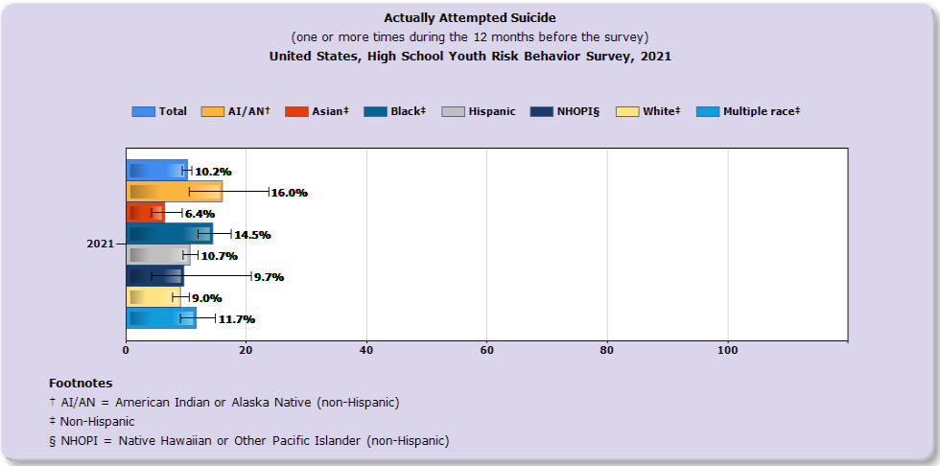

July 29:
The Puerto Rican Festival of Massachusetts
When: 12 pm – 10 pm
Where: 1 City Hall Square #500, Boston MA 02201
Description: The Annual Puerto Rican Festival of Massachusetts will be held July 29 and 30 at Boston City Hall! Come immerse yourself in our rich Puerto Rican culture and enjoy music performances and delicious Puerto Rican food!

July 30:
South/Central American Cuisine:
Beef empanadas
Pupusas
Birria

July 31:
Celebrate your culture and community!
Make your favorite family recipe, go for a walk around your neighborhood, embrace your traditions!

